# Exercise 5 - Amazon Athena configuration and run queries using Athena against baseball data replicated to Amazon S3

In this exercise, you will setup Amazon Athena to interactively run ad-hoc queries against baseball data stored on Amazon S3 bucket that was replicated through AWS Database Migration Service (DMS) and processed via a Glue ETL job and stored in Parquet format.

Amazon Athena is an interactive query service that makes it easy to analyze data directly in Amazon Simple Storage Service (Amazon S3) using standard SQL. You can point Athena at your data stored in Amazon S3 and begin using standard SQL to run ad-hoc queries and get results in seconds. Athena is serverless, so there is no infrastructure to setup or manage, scales automatically executing queries in parallel and you pay only for the queries you run. For an overview of Amazon Athena, you can refer to AWS documentation here:

<http://docs.aws.amazon.com/athena/latest/ug/what-is.html>

**Step 1:**

* Verify the baseball data on Amazon S3 in the parquet folder in the target S3 bucket.
* Refer to exercise 3 for Amazon S3 bucket name used as replication target. The bucket name is also listed on the CloudFormation stack outputs tab as S3BucketName. You will see a different S3 bucket name than what is shown below based on stack creation

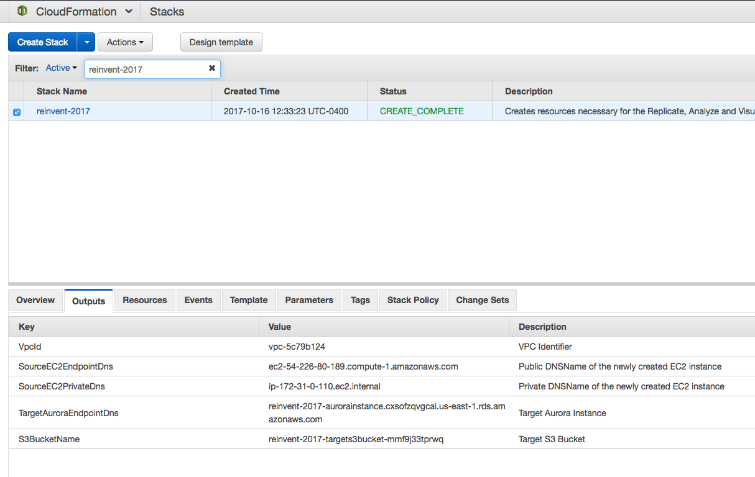

* Within the Amazon S3 bucket, you should see a folder parquet as below:

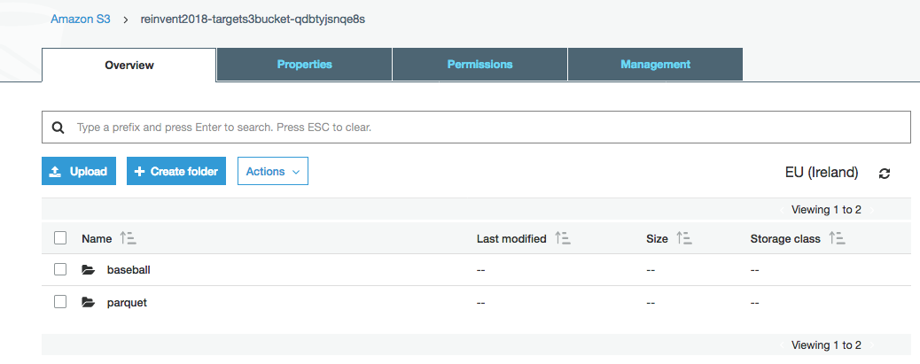

* If you browse through the subfolders, you should see a part-00000-<uid>.snappy.parquet file

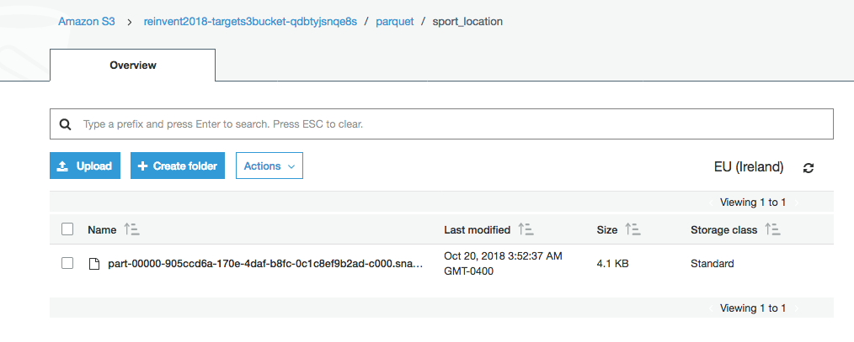

Step 2:

* On the AWS Console, under the drop-down Services, select Athena listed under Analytics section
* You will be taken to the Athena console as shown below:



* Click on “Get Started”
* If you are prompted with the Tutorial window (below), click the “X” in the upper right hand corner to close the window
* You should now see the following window:

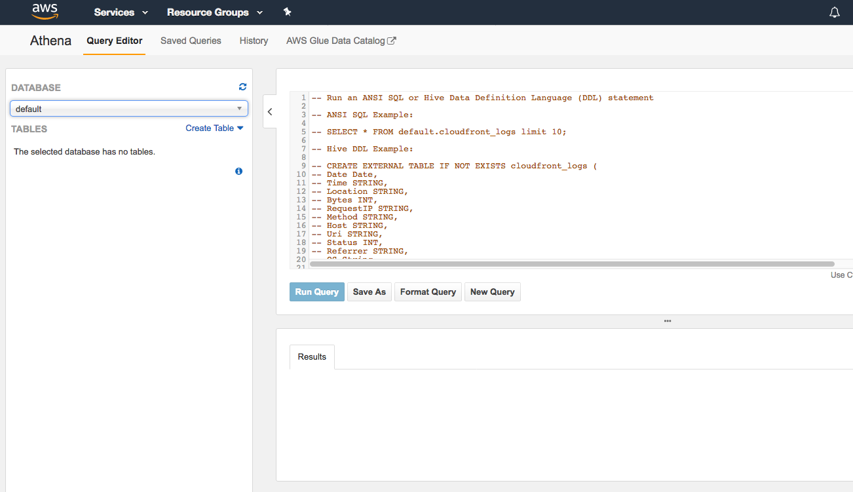

* In Athena, tables and databases are metadata definitions that define a schema for underlying source data. Athena uses the AWS Glue Data Catalog to store and retrieve this metadata, using it when you run queries to analyze the underlying dataset. Databases are simply a logical grouping of tables to help you organize. Like tables, they consist only of metadata.
* The metadata for a table tells Athena where the data is stored in Amazon S3, specifies structure of source data, specifies schema of the table and so on.
* When you query an existing table, under the hood, Amazon Athena uses Presto, a distributed SQL engine
* Let’s get started by creating a database using Athena Query Editor. Remember that Athena can use the Glue data catalogue so you at this point you could begin running queries against the **baseball-crawler-db** database that should be available in the database drop-down menu in the left panel. For this lab however, we will create a new database using the parquet files from the ETL jobs ran previously. Use the command below to copy/paste to the Athena Query Editor
  + Create database baseball;

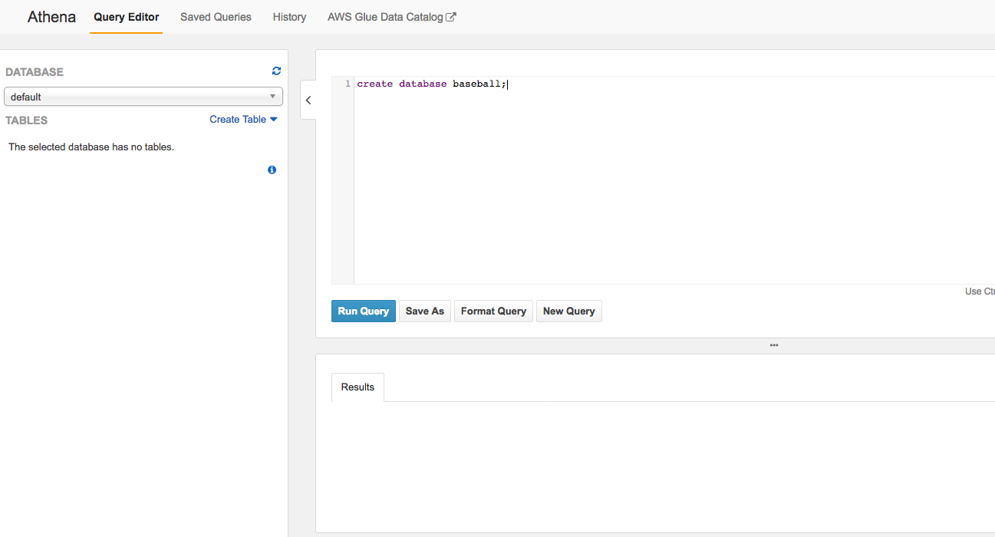

* Hit Run Query button. This will create baseball database object in Athena
* You will receive Query Successful message in the Results Window

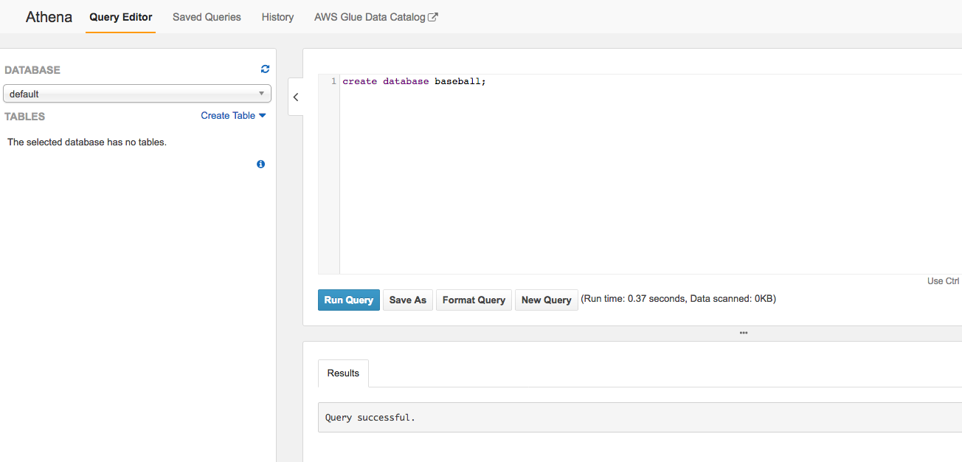

* On the left panel under Database, now select baseball. You will notice, this database does not have any tables defined yet. We will now create database tables using the same Athena Query Editor

**Step 3:**

* We will create 4 tables within baseball database before running queries against the data, each table corresponding to a Glue ETL job run in lab 4.
  + Sporting_event_ticket
  + Sport_location
  + Sport_team
  + Sporting_event
* Use the provided AthenaQueries_reinvent_workshop.txt file, open with a text editor and copy paste table creation syntax one at a time to Athena Query Editor or use the following syntax specified in this document below
* First table creation – sporting_event_ticket. Copy and paste the following create table syntax onto the Athena Query Editor. **Important**: before pasting the below code, replace S3 bucket name with your bucket name assigned. Make sure the database baseball is selected on the left panel before executing:

CREATE EXTERNAL TABLE IF NOT EXISTS baseball.sporting_event_ticket (

`id` bigint,

`sporting_event_id` bigint,

`sport_location_id` bigint,

`seat_level` bigint,

`seat_section` bigint,

`seat_row` string,

`seat` bigint,

`ticketholder_id` string,

`ticket_price` double

)

STORED AS PARQUET

LOCATION 's3://**<your S3 bucket location>**/parquet/sporting_event_ticket/'

TBLPROPERTIES ("parquet.compress"="SNAPPY");

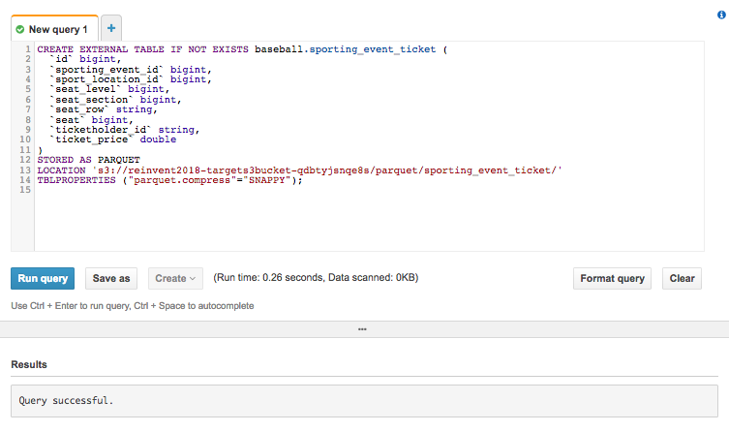

* Hit Run Query to execute create table statement. You should receive a Query Successful Result. If you get errors, make sure the S3 bucket name is correct, pay attention to white space while copy/paste
* You should see sporting_event_ticket table show up in the left panel under baseball database as below

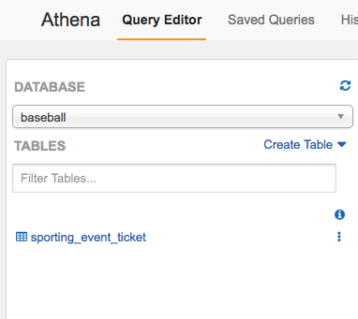

* Next to sporting_event_ticket, click on the 3 small dots and select Preview table to view 10 rows of the table on the right results tab as below:

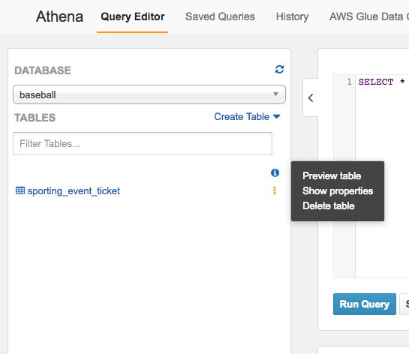

* This will ensure the data is displayed accurately with correct data types

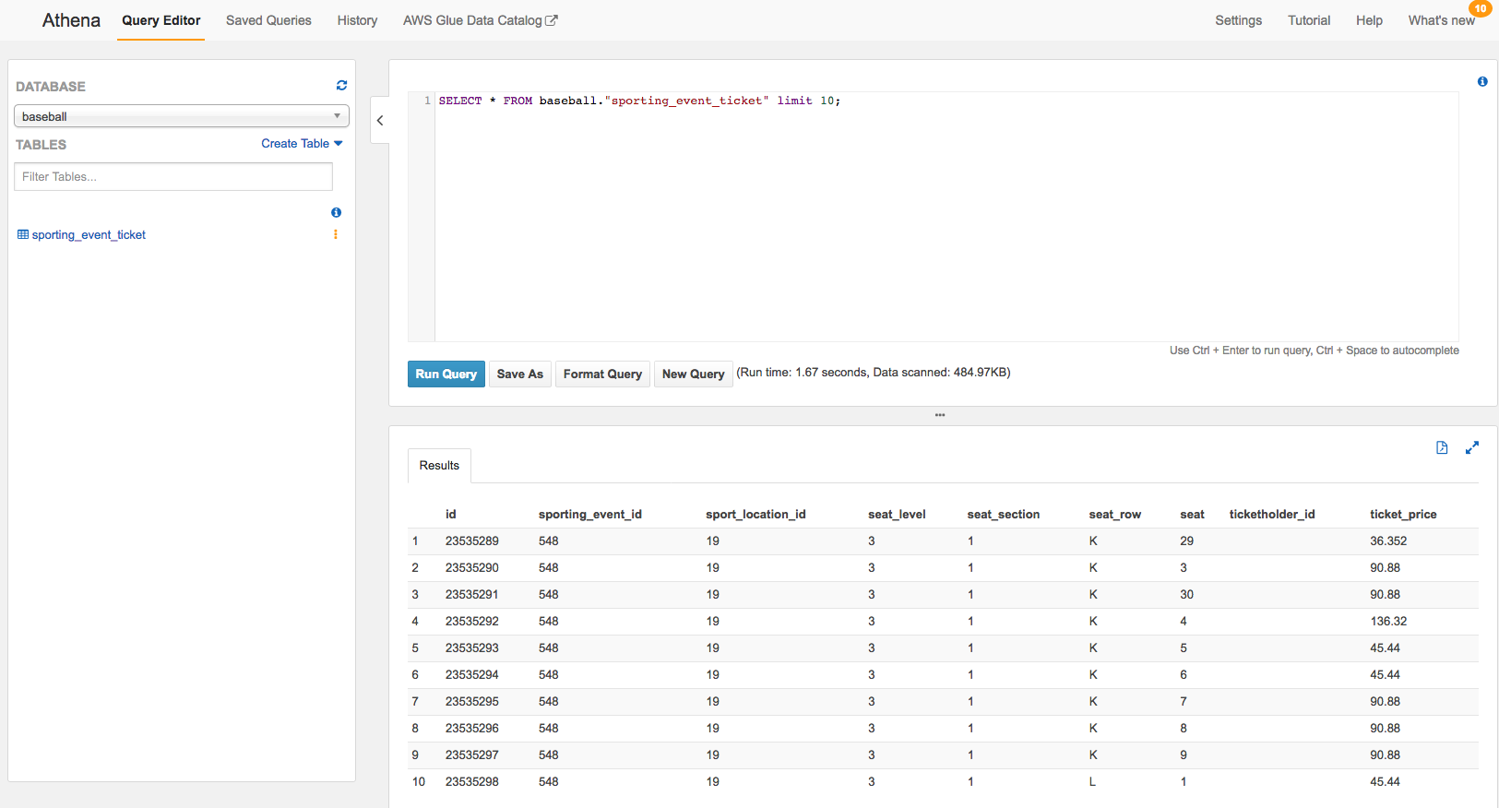

* Second table creation – sport_location. Copy and paste the following create table syntax onto the Athena Query Editor. **Important:** before pasting the below code, replace S3 bucket name with your bucket name assigned. Make sure the database baseball is selected on the left panel before executing:

CREATE EXTERNAL TABLE IF NOT EXISTS baseball.sport_location (

`id` bigint,

`name` string,

`city` string,

`seating_capacity` bigint,

`levels` bigint,

`sections` bigint

)

STORED AS PARQUET

LOCATION 's3://**<your S3 bucket location>/**parquet/sport_location/'

TBLPROPERTIES ("parquet.compress"="SNAPPY");

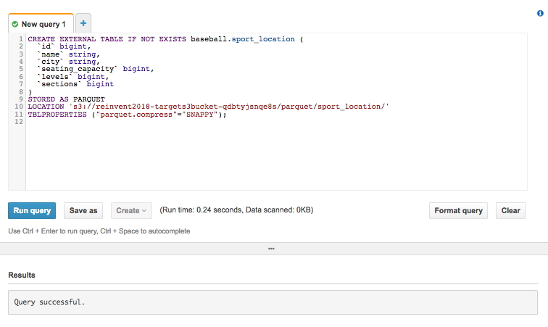

* Hit Run Query to execute create table statement. You should receive a Query Successful Result. If you get errors, make sure the S3 bucket name is correct, pay attention to white space while copy/paste
* You should see sport_location table show up in the left panel under baseball database as below

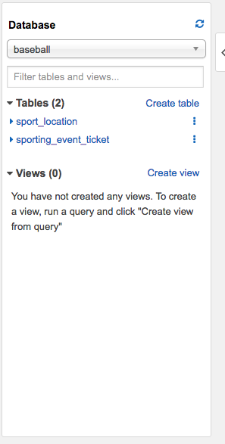

* Next to sport_location, click on the 3 small dots and select Preview table to view 10 rows of the table on the right results tab
* This will ensure the data is displayed accurately with correct data types

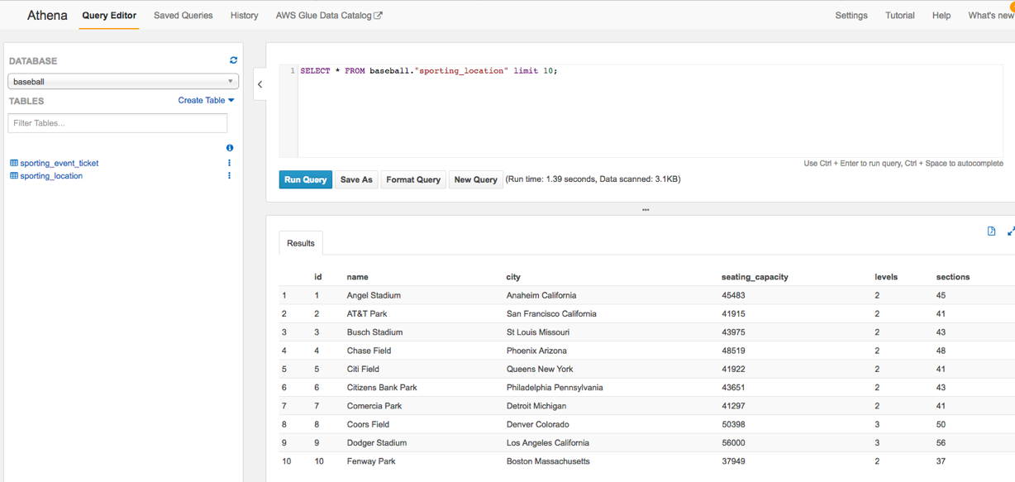

* Third table creation – sport_team. Copy and paste the following create table syntax onto the Athena Query Editor. Important before pasting the below code, replace S3 bucket name with your bucket name assigned. Make sure the database baseball is selected on the left panel before executing:

CREATE EXTERNAL TABLE IF NOT EXISTS baseball.sport_team (

`id` int,

`name` string,

`abbreviated_name` string,

`home_field_id` int,

`sport_type_name` string,

`sport_league_short_name` string,

`sport_division_short_name` string

)

STORED AS PARQUET

LOCATION 's3://<your S3 bucket location>/parquet/sport_team/'

TBLPROPERTIES ("parquet.compress"="SNAPPY");

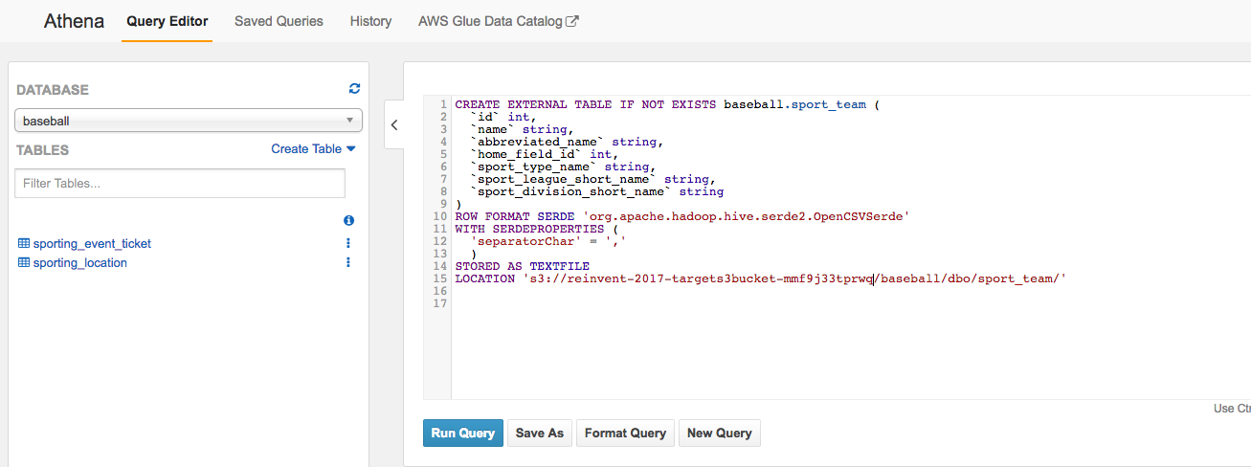

* Hit Run Query to execute create table statement. You should receive a Query Successful Result. If you get errors, make sure the S3 bucket name is correct, pay attention to white space while copy/paste
* You should see sport_team table show up in the left panel under baseball database as below:

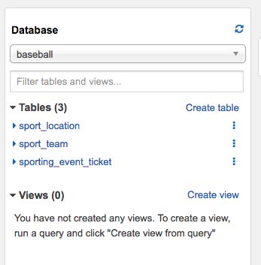

* Next to sport_team, click on the 3 small dots and select Preview table to view 10 rows of the table on the right results tab as below
* This will ensure the data is displayed accurately with correct data types

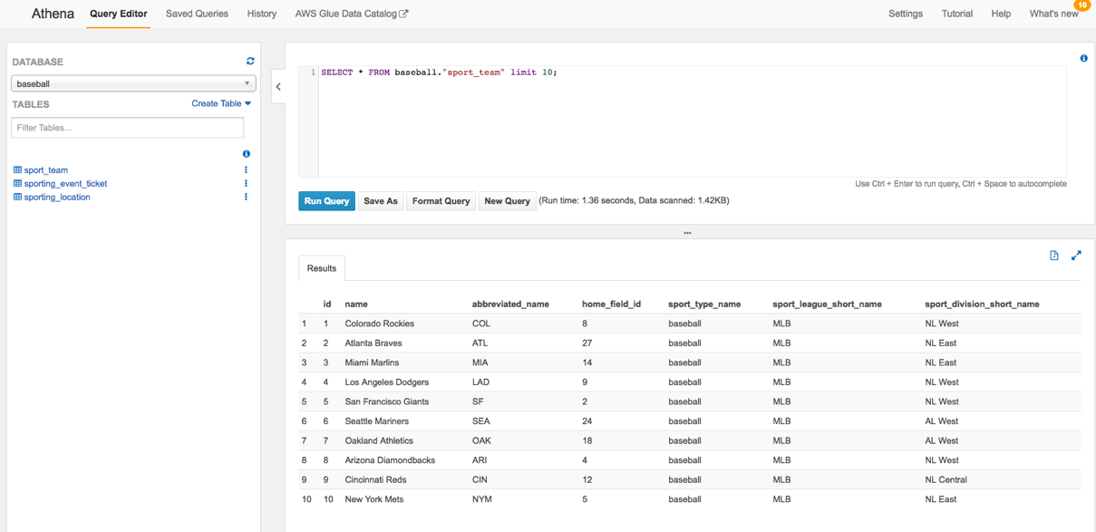

* Fourth table creation – sporting_event. Copy and paste the following create table syntax onto the Athena Query Editor. Important before pasting the below code, replace S3 bucket name with your bucket name assigned. Make sure the database baseball is selected on the left panel before executing:

CREATE EXTERNAL TABLE IF NOT EXISTS baseball.sporting_event (

`id` bigint,

`sport_type_name` string,

`home_team_id` int,

`away_team_id` int,

`location_id` int,

`start_date_time` string,

`sold_out` int,

`start_date` string

)

STORED AS PARQUET

LOCATION 's3://<your S3 bucket location>/parquet/sporting_event/'

TBLPROPERTIES ("parquet.compress"="SNAPPY");

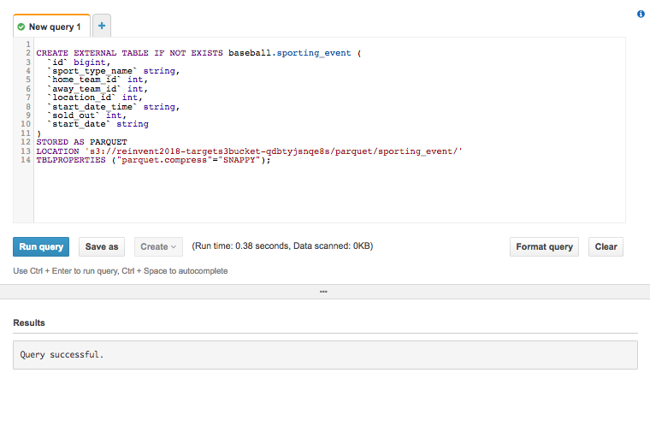

* Hit Run Query to execute create table statement. You should receive a Query Successful Result. If you get errors, make sure the S3 bucket name is correct, pay attention to white space while copy/paste
* You should see sporting_event table show up in the left panel under baseball database as below:

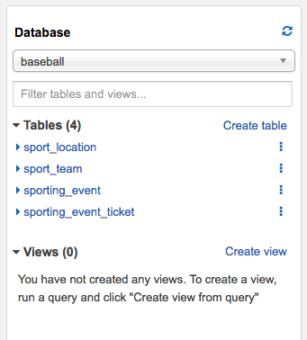

* Next to sporting_event, click on the 3 small dots and select Preview table to view 10 rows of the table on the right results tab as below
* This will ensure the data is displayed accurately with correct data types

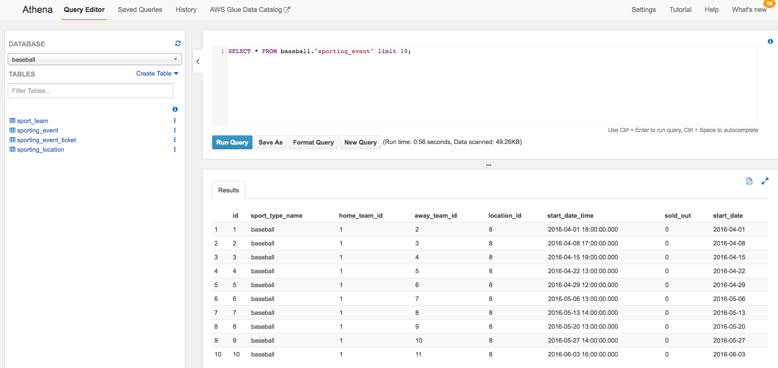

**Step 4: Query tables and Joins**

* Now that we have created the 4 tables on Amazon Athena, we can run queries on the table using standard ANSI SQL statements including Joins across tables
* Let us start querying the data. Again, use the provided AthenaQueries text file to copy/paste query syntax
* **Query 1:** **“Show all team names and home stadium”**. Copy and paste the following query to Athena Query Editor. Make sure **baseball** database is selected on the left panel before executing the query

select sport_team.id as "ID", sport_team.name as "Team Name", sport_location.name as "Stadium Name", sport_location.city as "Stadium City" from sport_team,sport_location where sport_team.home_field_id=sport_location.id;

* The Results window on the right should display teams with stadium. You can also download as a csv output by selecting the page symbol on top right in the output window as shown

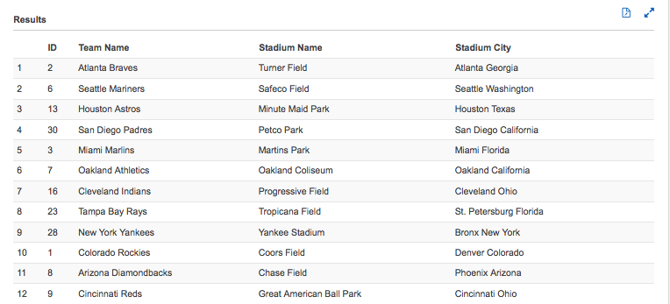

* **Query 2: Let’s query “Total number of games played in PNC park in Pittsburgh (location id 21)”.** Copy and paste the following query to Athena Query Editor. Make sure baseball database is selected on the left panel before executing the query

select count(*) as "Total games in PNC Park" from sporting_event where location_id=21;

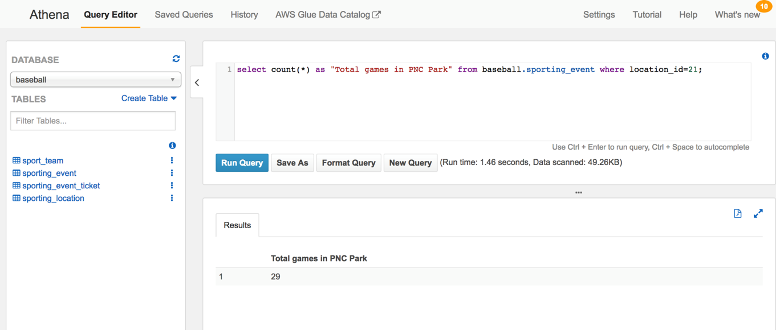

* The Results window on the right should display number of games in PNC Park.
* **Query 3: “Total number of level 2 seats (along with revenue) that were sold at AT&T Park in SFO for the entire season and Revenue in Dollars”.** Copy and paste the following query to Athena Query Editor. Make sure baseball database is selected on the left panel before executing the query

select count(*) as "Total L2 seats in AT&T Park", sum(ticket_price) as "Total Revenue in Dollars" from sporting_event_ticket where sport_location_id=2 and seat_level=2;

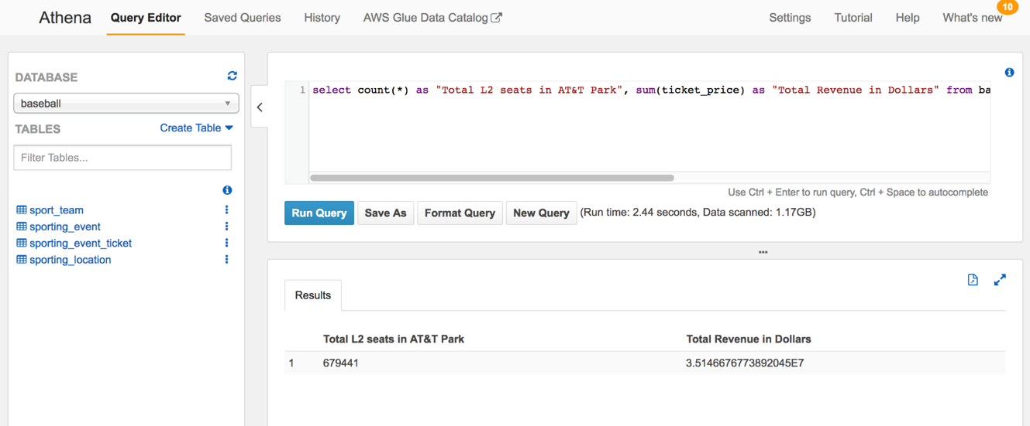

* The Results window on the right should display tickets sold and revenue
* **Query 4: “Revenue from each game in dollars”**. Copy and paste the following query to Athena Query Editor. Make sure baseball database is selected on the left panel before executing the query

select sporting_event_id, sum(ticket_Price) as revenue from sporting_event_ticket group by sporting_event_id order by sum(ticket_price) desc;

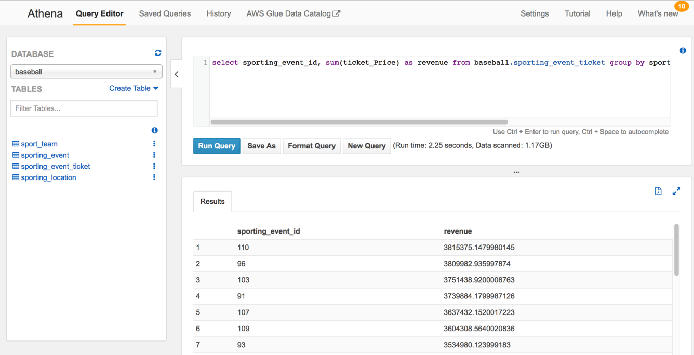

* The Results window on the right should display revenue from each game
* Go ahead and try your own queries on the tables created. Or you can rerun the same queries after selecting the **baseball-crawler-db** database to demonstrate the integration with Glue. Observe the differences in Run time and Data scanned after a successful query.

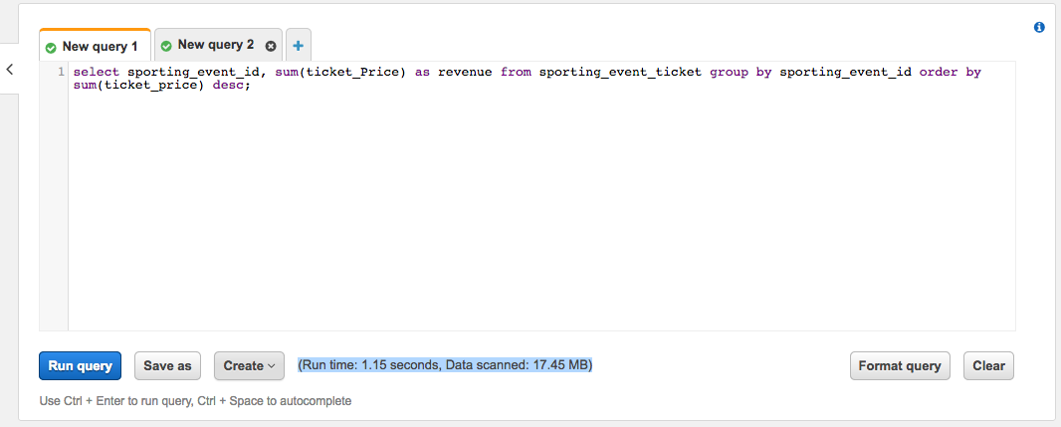

**Exercise Recap:**

* With this exercise, you were able to create database and tables in Amazon Athena for baseball dataset stored in Amazon S3
* Used Amazon Athena to interactively query baseball dataset stored in Amazon S3 to gain useful insights into the data without the need to setup and manage server or data analytics infrastructure